Prepaid Wallet
# Source: AI Source: Provided by: [Data Path: Persons Table -> ID Column: 1, Name_En Column: Motasem Essam] -> From: [ChatGPT] on [1/21/2026]
A Prepaid Wallet is a type of digital wallet that requires the user to load or "top up" money in advance. This balance is stored in the wallet and used for future transactions like online purchases, bill payments, or peer-to-peer transfers. It functions similarly to a prepaid card or stored-value account.

✅ Key Characteristics of Prepaid Wallets:
# Source: AI Source: Provided by: [Data Path: Persons Table -> ID Column: 1, Name_En Column: Motasem Essam] -> From: [ChatGPT] on [1/21/2026]
- Stored Value System
  - Funds are preloaded into the wallet from a bank account, card, or cash at agents.
  - The user spends from this stored balance.
- Not Always Bank-Linked
  - A bank account is not required, although many wallets support linking for easier top-ups.
- Wallet ID
  - The wallet may be linked to a mobile number, email, or app account.
- Spending Limited to Wallet Balance
  - Users can’t overspend—they can only transact up to the amount in the wallet.

🔄 Examples of Prepaid Wallets:
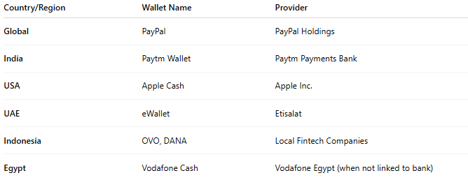

Country/Region | Wallet Name | Provider
Global | PayPal | PayPal Holdings
India | Paytm Wallet | Paytm Payments Bank
USA | Apple Cash | Apple Inc.
UAE | eWallet | Etisalat
Indonesia | OVO, DANA | Local Fintech Companies
Egypt | Vodafone Cash | Vodafone Egypt (when not linked to bank)

🛠️ How It Works:
# Source: AI Source: Provided by: [Data Path: Persons Table -> ID Column: 1, Name_En Column: Motasem Essam] -> From: [ChatGPT] on [1/21/2026]
- User Registers on a wallet platform or mobile app.
- Funds Are Loaded via:
  - Bank transfer
  - Credit/debit card
  - In-person deposit (at agent/retail locations)
- User uses wallet for:
  - Online & offline purchases
  - Utility & mobile bill payments
  - P2P transfers
  - Booking services (e.g., transport, movie tickets)
- Top-Up Again when balance is low.

✅ Advantages:
# Source: AI Source: Provided by: [Data Path: Persons Table -> ID Column: 1, Name_En Column: Motasem Essam] -> From: [ChatGPT] on [1/21/2026]
- Easy to set up (low KYC for basic use)
- Great for budgeting and controlled spending
- Safe from overspending (no credit risk)
- Widely accepted by online merchants and apps
- Works well for unbanked or underbanked populations

⚠️ Limitations:
# Source: AI Source: Provided by: [Data Path: Persons Table -> ID Column: 1, Name_En Column: Motasem Essam] -> From: [ChatGPT] on [1/21/2026]
- Requires manual top-up
- Limited features if not linked to a bank
- May have wallet balance caps (based on regulation)
- Some providers charge inactivity or withdrawal fees

🆚 Compared with Other Wallet Types:
# Source: AI Source: Provided by: [Data Path: Persons Table -> ID Column: 1, Name_En Column: Motasem Essam] -> From: [ChatGPT] on [1/21/2026]
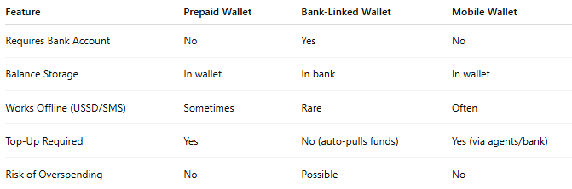

Feature | Prepaid Wallet | Bank-Linked Wallet | Mobile Wallet
Requires Bank Account | No | Yes | No
Balance Storage | In wallet | In bank | In wallet
Works Offline (USSD/SMS) | Sometimes | Rare | Often
Top-Up Required | Yes | No (auto-pulls funds) | Yes (via agents/bank)
Risk of Overspending | No | Possible | No

🧠 Use Cases:
# Source: AI Source: Provided by: [Data Path: Persons Table -> ID Column: 1, Name_En Column: Motasem Essam] -> From: [ChatGPT] on [1/21/2026]
- Teens or students without bank accounts
- Travel wallets with preloaded foreign currency
- Gaming, e-commerce, ride-hailing apps
- Corporate gift cards and employee incentives

